Casual Jobs Database V.1

Client Acceptance & Feedback Form



**Front-end Design**

To:

Clement Sudhakar Swarnappa  
*Senior Academic Staff Member*

School of Information Technology  
DDI: +64 4 830 3130  
Email: clement.sudhakar@weltec.ac.nz  
URL: www.weltec.ac.nz  
Post: Private Bag 39803, Lower Hutt 5045  
Wellington, New Zealand

Project Team:

Supun Chandra Malimage – Project Manager

Kalaivani Ilango – Team Member

Ruban Ravi Sebastian – Team Member

Table of Contents

Casual Jobs Database V.1 1

Client Acceptance & Feedback Form 3

Task description: 3

Casual Jobs V.1 homepage: 3

Register now: 4

Login: 6

Employer login: 6

Employer dashboard: 7

Job Seeker login: 10

Job Seeker dashboard: 10

About us: 13

Contact us: 13

Overall Client feedback: 14

Action Plan on this Milestone: 14

Next steps: 14

# Client Acceptance & Feedback Form

|  |  |
| --- | --- |
| Milestone – Front-end design approval | |
| Project Name: Casual Jobs Database V.1 | Client Name: Clement Sudhakar Swarnappa |
| Project Start date: July 6th, 2020 | Project End date: October 9th, 2020 |
| Milestone: Front-end design approval | Finished date: September 22nd, 2020 |
| **Introduction of Milestone:**   * Design prototype (UI) * Working model of employer registration, employer profile * Working model of job seeker registration, job seeker profile * Reporting structure and responsive design | |

## Task description:

Based on the Rapid Application Development methodology, we have completed design prototype of front-end. This UI has the features of employer registration and profile creation, Job seeker registration and profile creation, homepage with nav integration, reporting structure and responsive design.

## Casual Jobs V.1 homepage:

Below attached is the image of home page which has the features as follows.

* Registration for the first-time user
* Login for already registered user
* Navigate directly to employer or job seeker profile
* About and contact us options
* Details about Casual Jobs Database V.1 application with its benefits
* Ratings and reviews by users

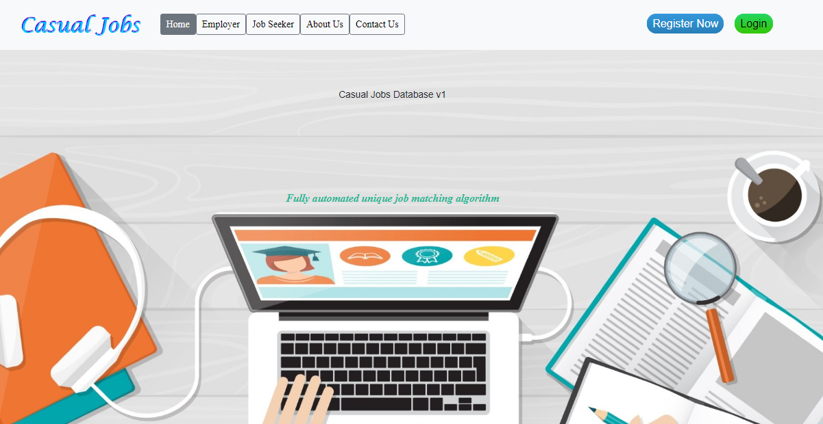

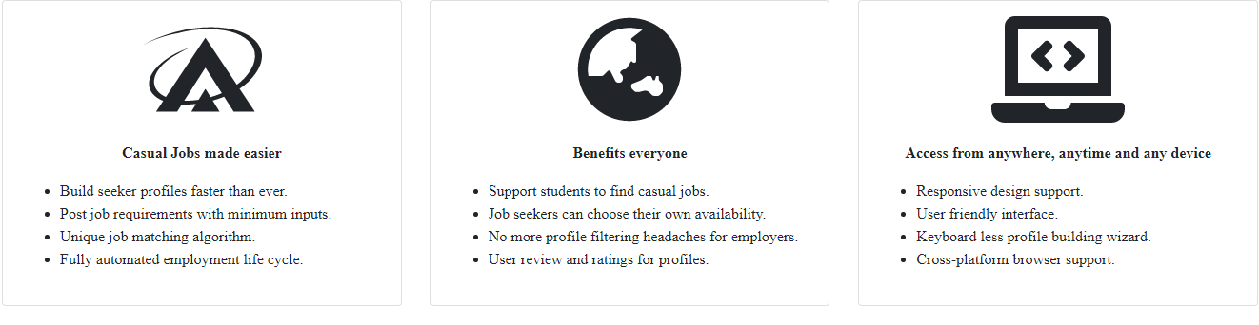

## Register now:

“Register now” option allows employer and job seeker to register themselves to access the casual jobs database

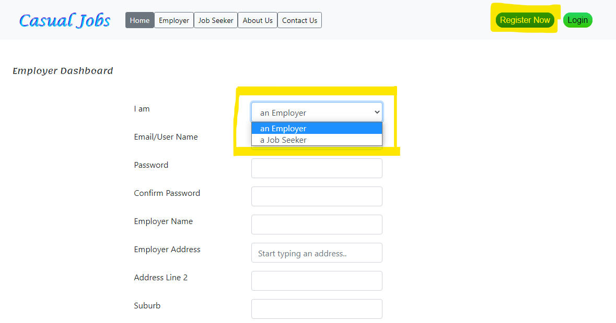

## Login:

Already registered employer or job seeker can directly access the login button by entering their credentials

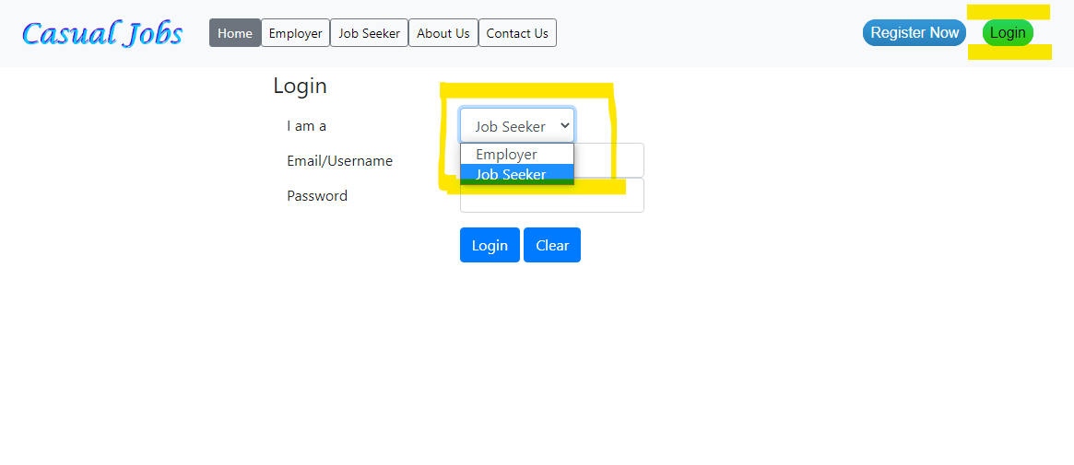

## Employer login:

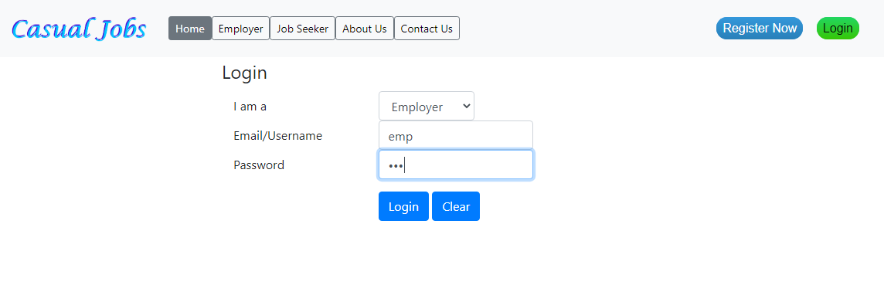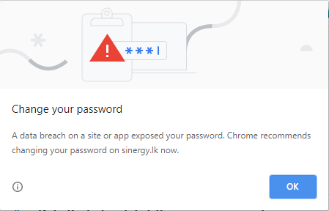

## Employer dashboard:

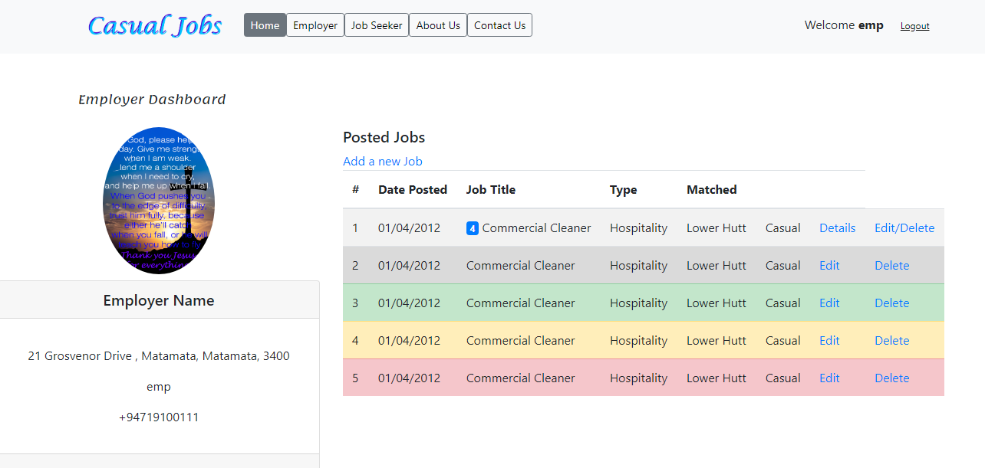

By clicking add new job in the employer dashboard, employer can add jobs, requirements to find the match

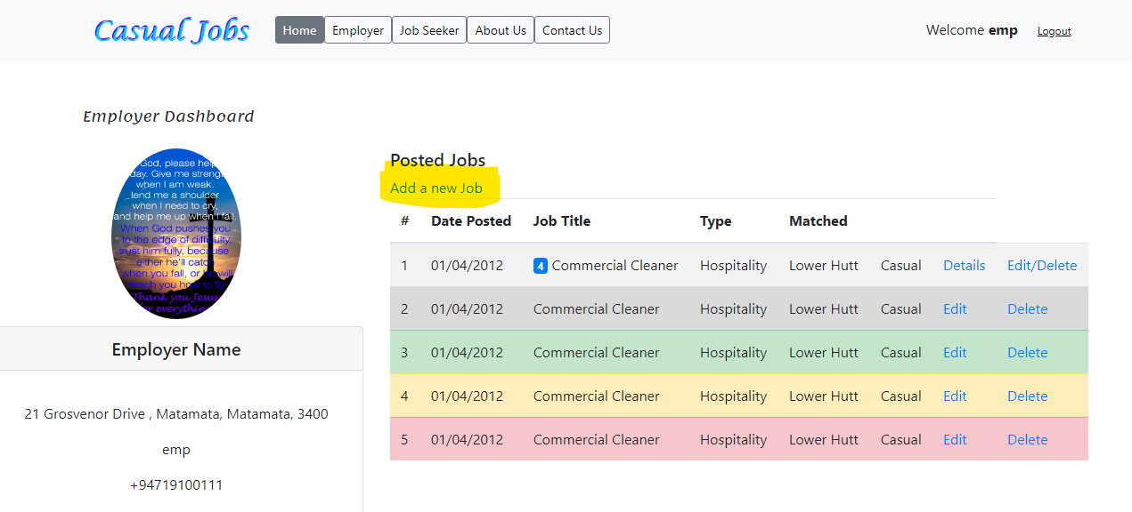

By entering the required details, employers can successfully complete adding jobs in the portal

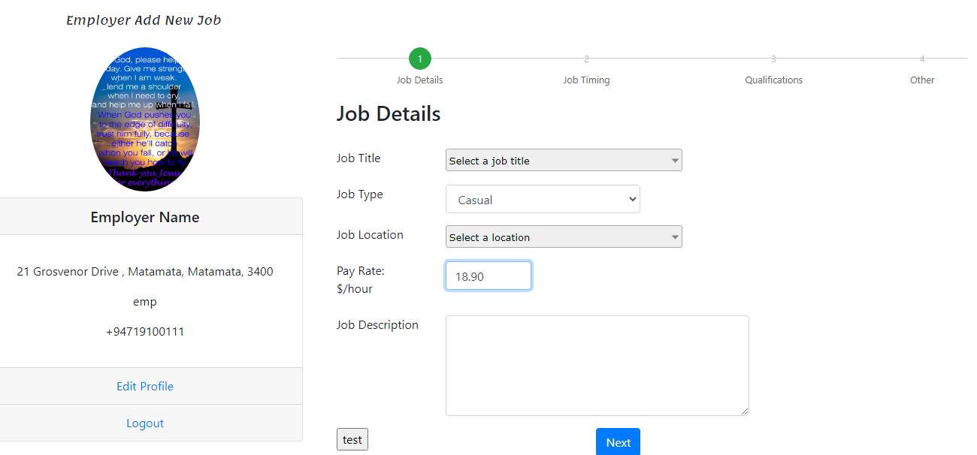

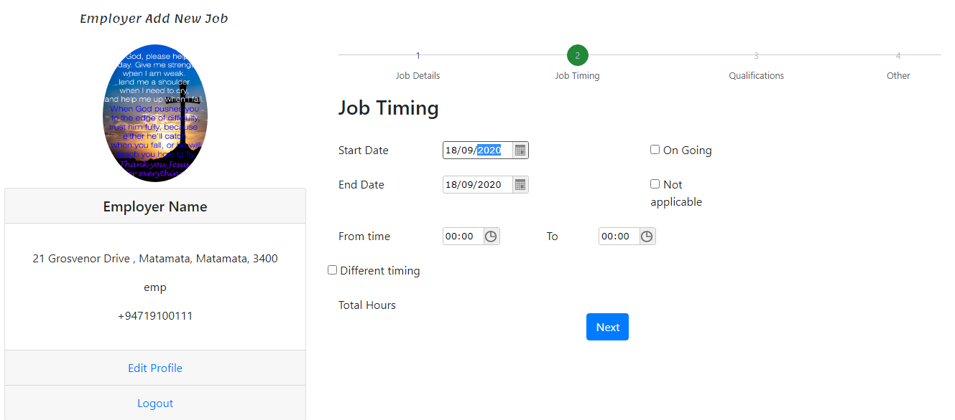

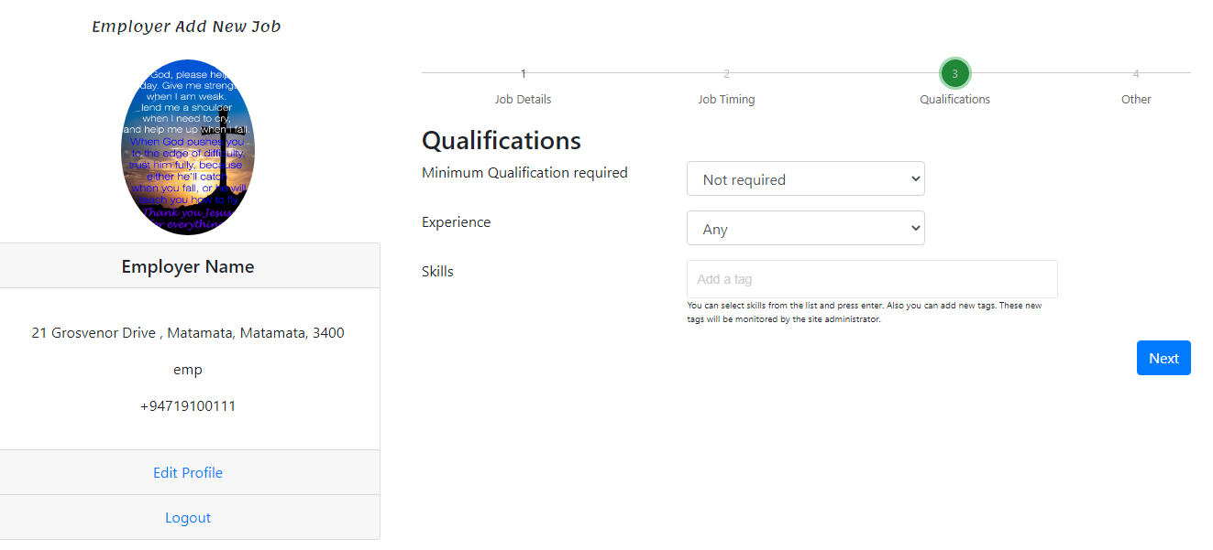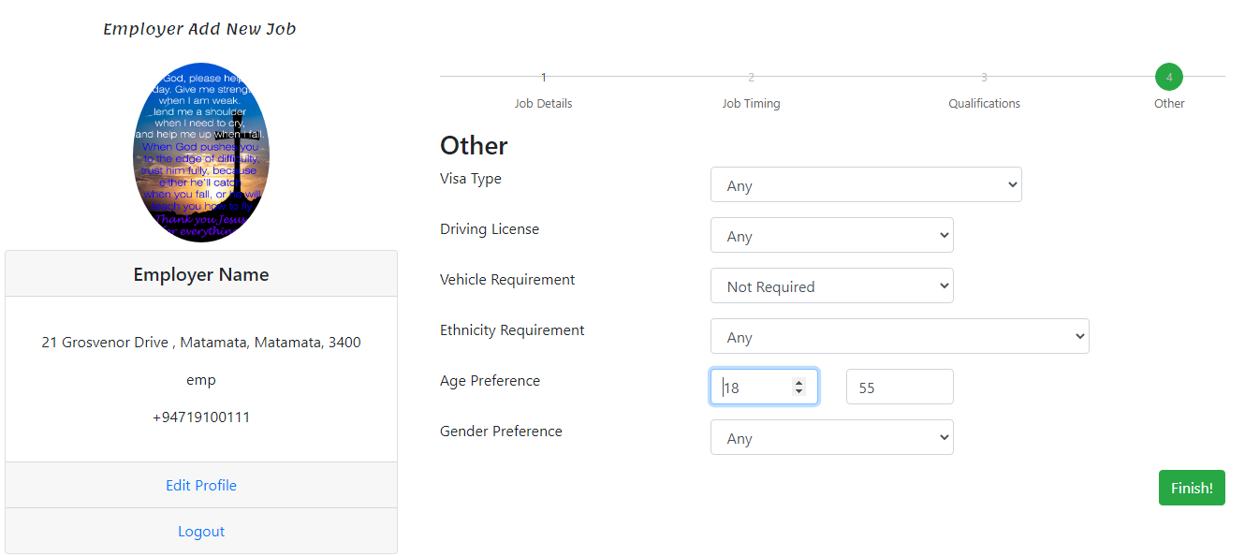

## Job Seeker login:

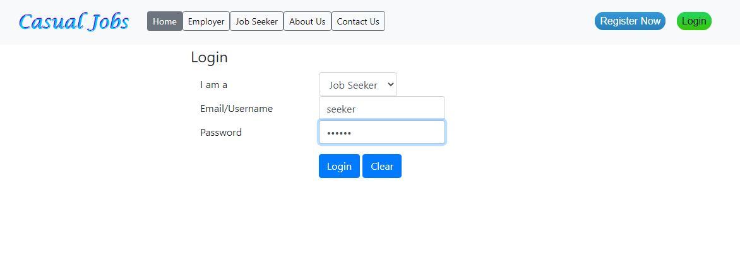

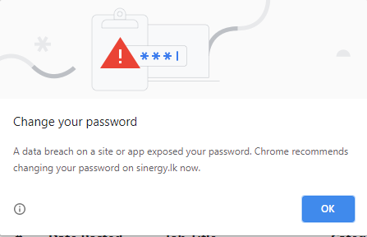

## Job Seeker dashboard:

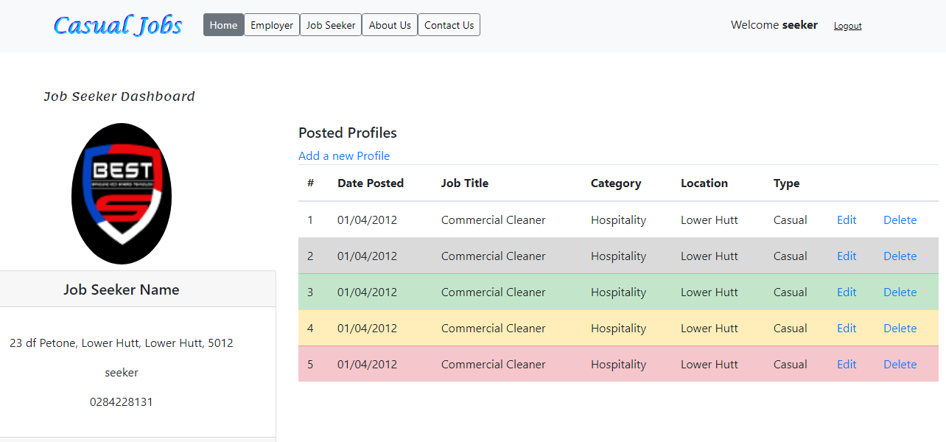

By clicking “Add a new profile” option, job seeker can add their profile based on their requirement.

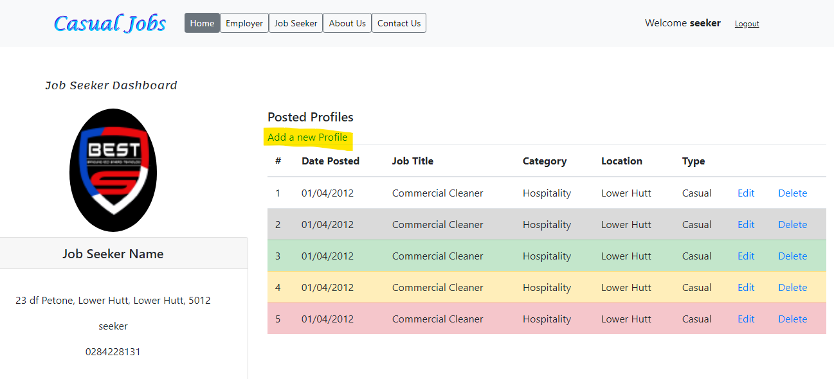

By entering the required details, Job seeker can successfully complete adding their profile in the portal

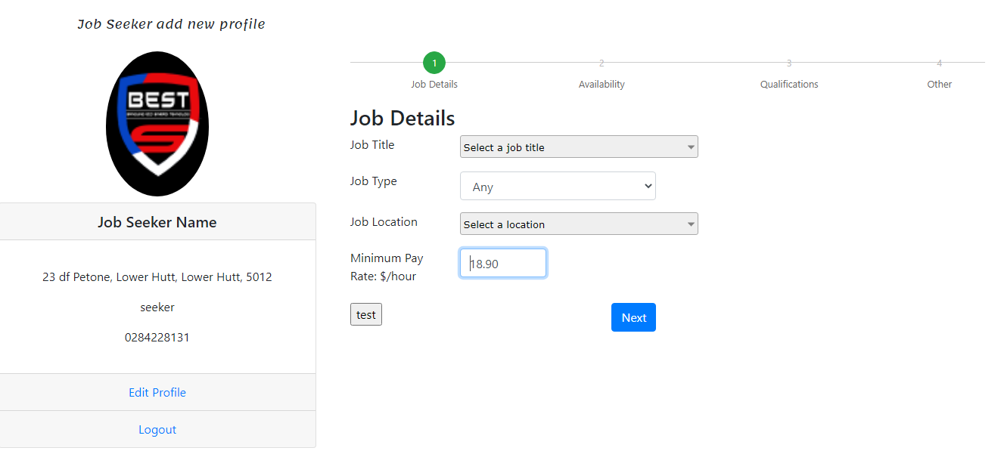

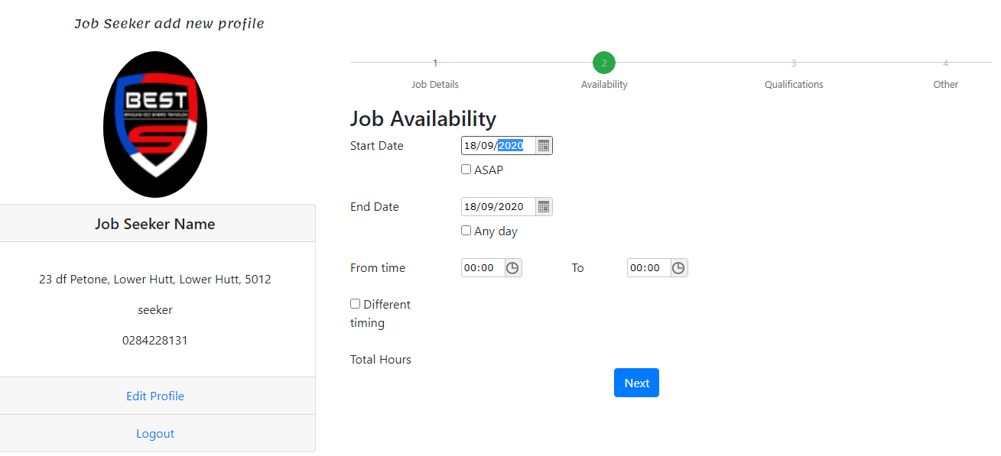

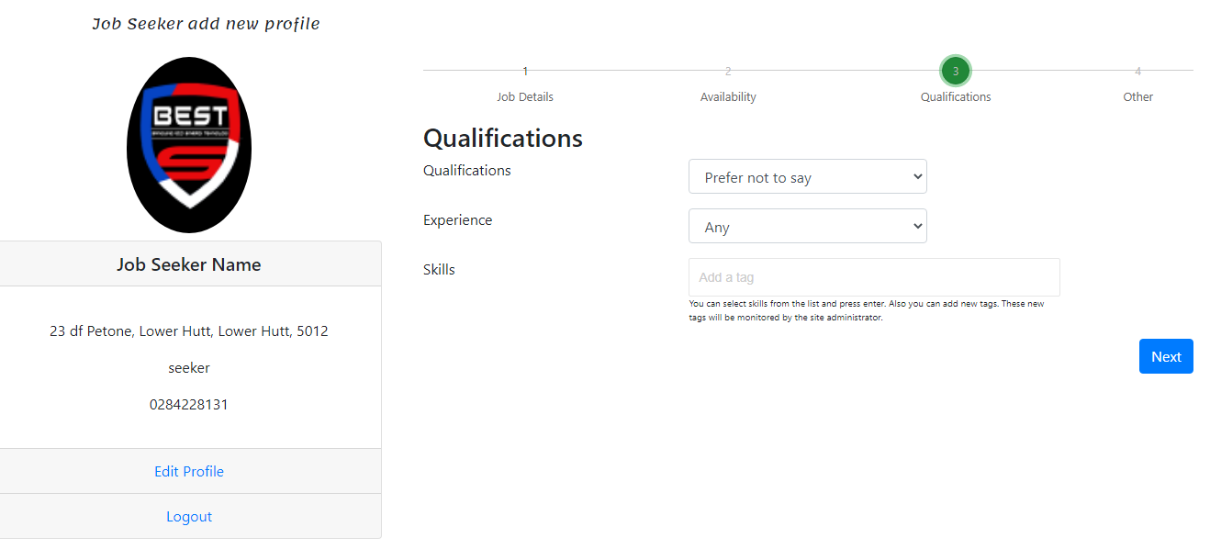

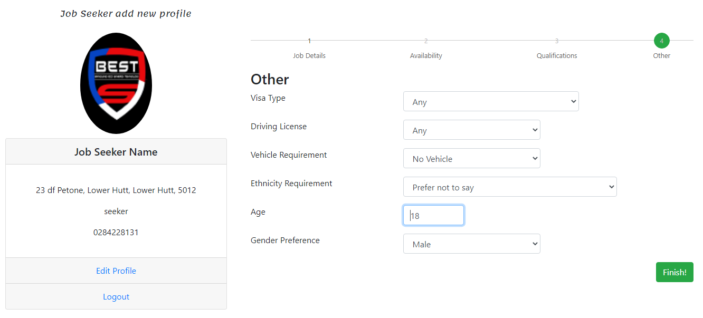

## About us:

This section provides the detailed description about who we are, the reason for creating this application, who will be benefited by using this application etc., 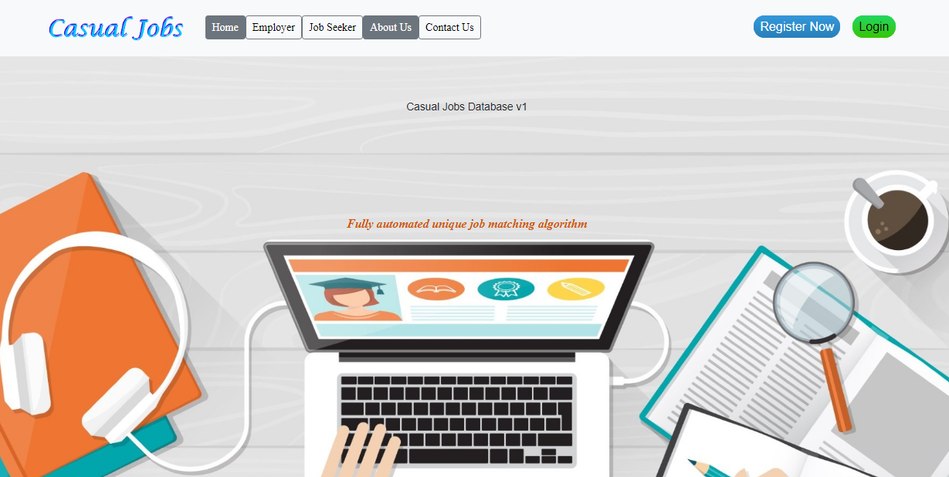

## Contact us:

This section helps and provide accessibility to employer and job seeker to contact us for registering with Casual Jobs Database, login, careers, future opportunities etc.,

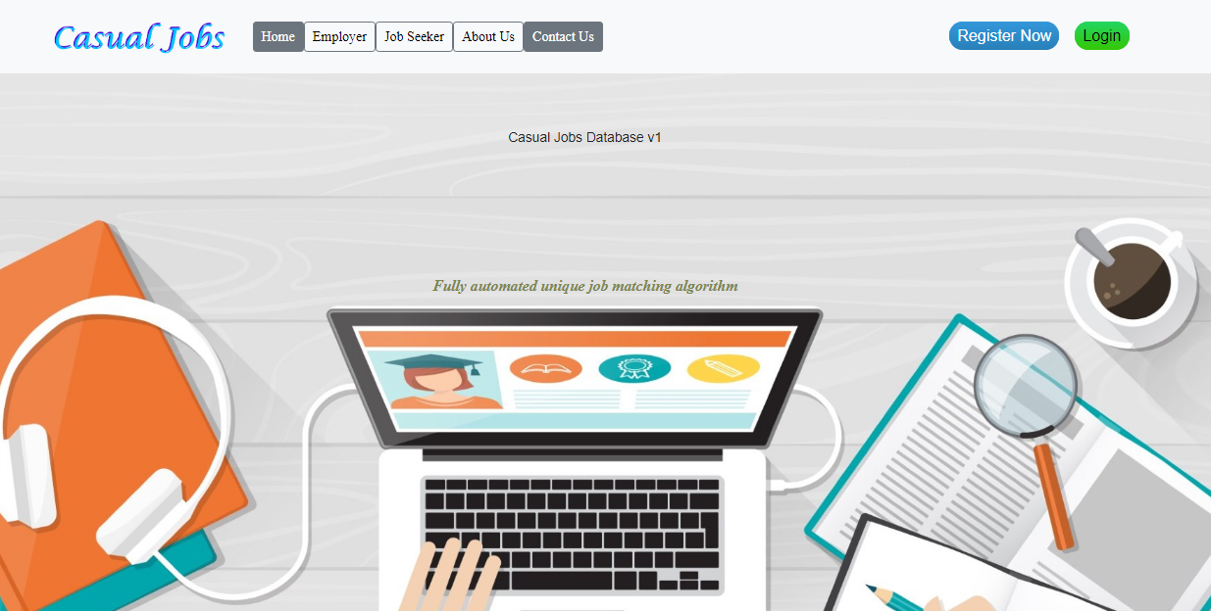

## Overall Client feedback:

## Action Plan on this Milestone:

## Next steps:

**Milestone: Design prototype**

In this milestone, we have planned to do the Back-end development with Employer panel, Job seeker panel and complete the Back end and process modelling

|  |
| --- |
| **Client Name:** _____________________________________________________________________  **Signature:** _____________________________________________________________________  **Date:** _____________________________________________________________________ |